GRADE 7 ACCELERATED · UNIT 2 · LESSON 4
Approximating Irrational Numbers
Additional Practice 7A.02.04 ANSWER KEY

1. Find the value of each. If there is no real value, write “no real value.”
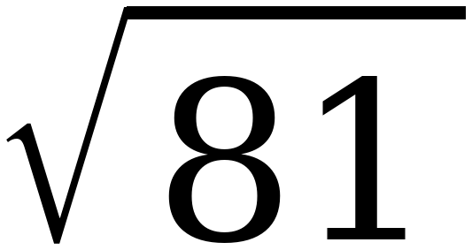  9 | 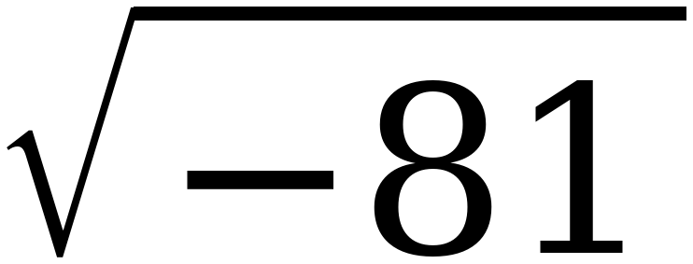  no real value | 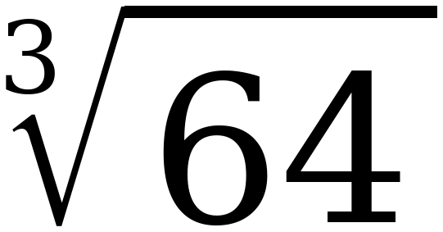  4 | 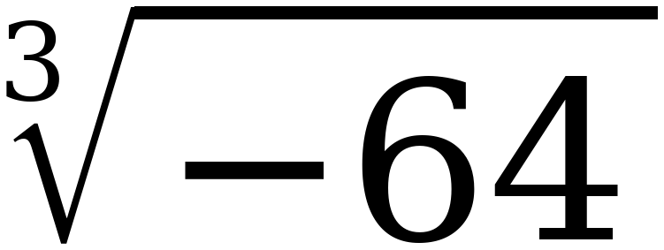  −4

Cube roots accept negatives; square roots do not.
2. Why is there no real value for when there is one for ?
Squaring any real number gives a positive result or zero, so nothing squares to −81.
Cubing a negative gives a negative, because three negative factors leave one negative behind. So (−4)³ = −64.
The point needs both halves — why one is refused and why the other is not.
3. Select ALL of the numbers below that are irrational.
☐ | 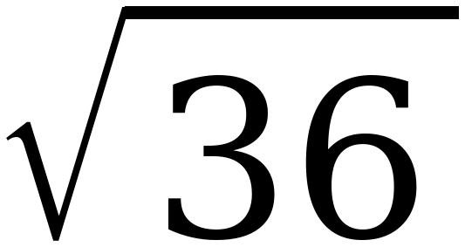 | ☒ | 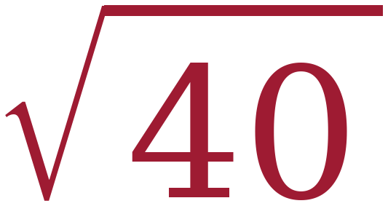
☐ | 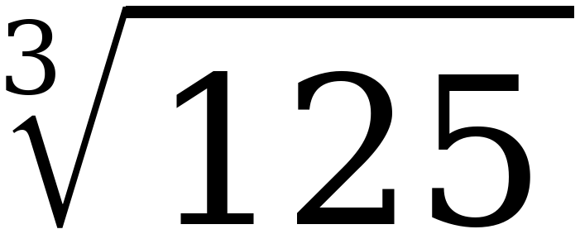 | ☒ | 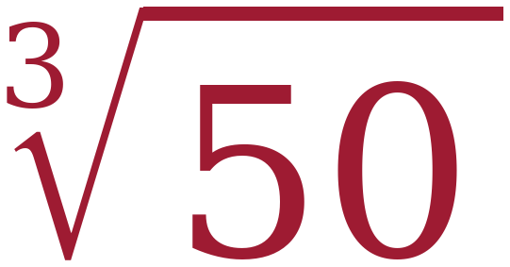
☒ | 2π | ☐ | 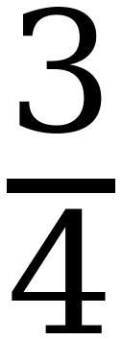

Three of the six. √36 = 6 and ∛125 = 5 are whole numbers, and 3/4 is a ratio of integers. 2π is π scaled, and scaling an irrational number by a NON-ZERO rational one leaves it irrational.
Questions 4 and 5: name the perfect squares or cubes first, then the root.
4. 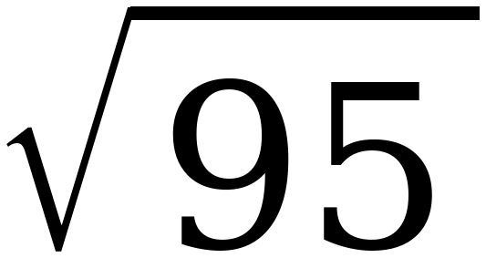
a. 95 lies between the perfect squares ______ and ______.
81 and 100
b. So the root lies between the integers ______ and ______.
9 and 10
c. The root is closer to ______.
10
95 − 81 = 14 and 100 − 95 = 5, so 95 sits nearer 100.

5. 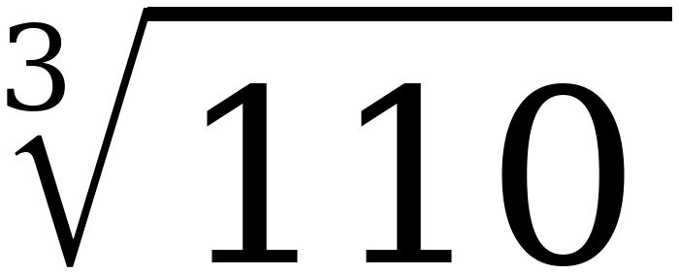
a. 110 lies between the perfect cubes ______ and ______.
64 and 125
b. So the root lies between the integers ______ and ______.
4 and 5
c. The root is closer to ______.
5
110 − 64 = 46 and 125 − 110 = 15, so 110 sits nearer 125. Both cubes are on the list from Lesson 3.

6. Approximate to the nearest tenth. Fill in the table, then decide.
Try | Result | How far from 95
9.7 × itself | 94.09 | 0.91
9.8 × itself | 96.04 | 1.04

To the nearest tenth, the value is 9.7
9.7 misses by 0.91 and 9.8 misses by 1.04. It is close, which is worth pointing out — the two whole numbers were not close at all.
7. Approximate to the nearest tenth. Fill in the table, then decide.
Try | Result | How far from 110
4.7 cubed | 103.823 | 6.177
4.8 cubed | 110.592 | 0.592

To the nearest tenth, the value is 4.8
4.8 misses by only 0.592 while 4.7 misses by 6.177.
8. Use ≈ 9.747 to approximate each expression to the nearest tenth.

Expression | Approximate Value
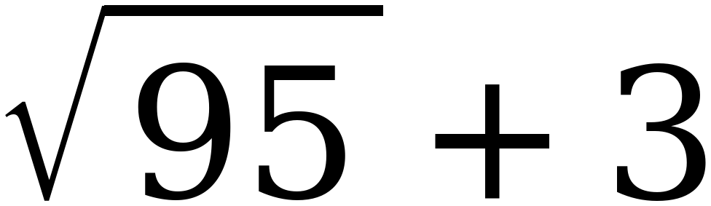 | 12.7
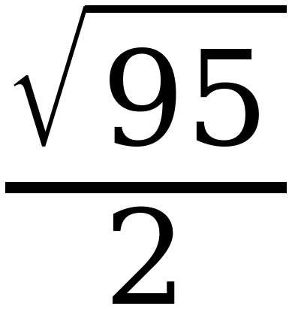 | 4.9
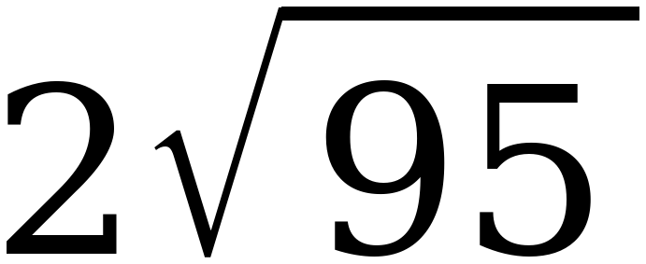 | 19.5

The sheet gives three decimal places on purpose. Rounding to 9.7 first and then doubling gives 19.4, which is a tenth short of the right answer. Question 11 is this idea asked directly.
9. Approximate the value of each expression to the nearest tenth.

 | Expression | Approximate Value
A |  | 4.8
B | 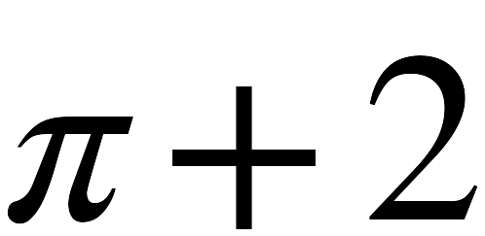 | 5.1
C | 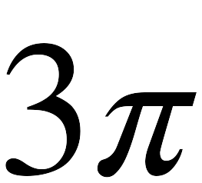 | 9.4
D |  | 9.7

10. Plot and label A, B, C and D on the number line.
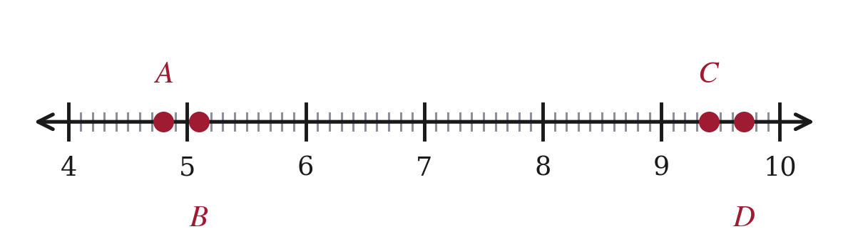
A = 4.8, B = 5.1, C = 9.4, D = 9.7. All four land on a tenth mark.
11. Marcus says that because 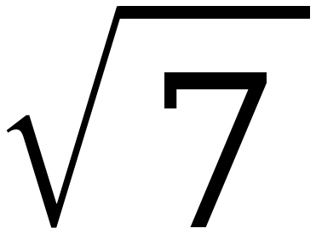 ≈ 2.6, the value of 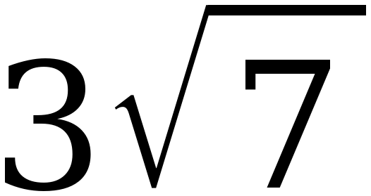 is 7.8. His calculator says 7.9. Who is right, and what went wrong?
The calculator is right. 3√7 = 7.937…, which is 7.9 to the nearest tenth.
Marcus rounded first and then multiplied. Rounding 2.6458 down to 2.6 lost 0.046, and tripling it lost 0.137.
Using √7 ≈ 2.65 gives 3 × 2.65 = 7.95, which rounds to 7.9 or 8.0 — better still, keep 2.646 and get 7.938.
Adding and subtracting are safe. Multiplying and dividing are not. Round last, or carry an extra place.

